**EXPT NO: 1 A python program to implement univariate regression DATE: 23.8.24 bivariate regression and multivariate regression.**

**AIM:**

To write a python program to implement univariate regression, bivariate regression and multivariate regression.

**PROCEDURE:**

Implementing univariate, bivariate, and multivariate regression using the Iris dataset involve the following steps:

**Step 1: Import Necessary Libraries**

First, import the libraries that are essential for data manipulation, visualization, and model building.

|  |
| --- |
| import numpy as np  import pandas as pd |
|  |
| import seaborn as sns |
|  |
| import matplotlib.pyplot as plt |
|  |
| from sklearn.model_selection import train_test_split  from sklearn.linear_model import LinearRegression  from sklearn.metrics import mean_squared_error, r2_score |

**Step 2: Load the Iris Dataset**

The Iris dataset can be loaded and display the first few rows of the dataset .

# Load the Iris dataset

iris = sns.load_dataset('iris')

# Display the first few rows of the dataset print(iris.head())

**OUTPUT :**

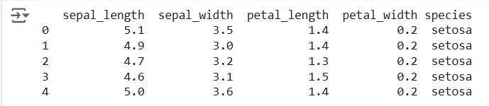

**Step 3: Data Preprocessing**

Ensure the data is clean and ready for modeling. Since the Iris dataset is clean, minimal preprocessing is needed.

|  |
| --- |
| # Check for missing values print(iris.isnull().sum()) |
|  |
| # Display the basic statistical details |
| print(iris.describe()) |

**OUTPUT :**

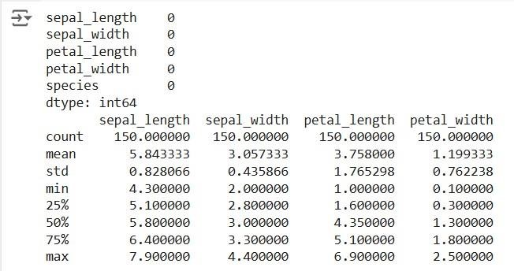

**Step 4: Univariate Regression**

Univariate regression involves predicting one variable based on a single predictor.

**4.1: Select the Features**

Choose one feature (e.g., sepal_length) and one target variable (e.g., sepal_width).

|  |
| --- |
|  |
| X_uni = iris[['sepal_length']] |
| y_uni = iris['sepal_width'] |

**4.2: Split the Data**

Split the data into training and testing sets.

Fit the linear regression model on the training data.

X_uni_train, X_uni_test, y_uni_train, y_uni_test = train_test_split(X_uni, y_uni,

test_size=0.2, random_state=42)

**4.3: Train the model**

|  |
| --- |
| uni_model = LinearRegression() |
| uni_model.fit(X_uni_train, y_uni_train) |

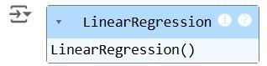

**4.4: Make Predictions**

Use the model to make predictions on the test data.

y_uni_pred = uni_model.predict(X_uni_test)

**4.5: Evaluate the Model**

Evaluate the model performance using metrics like Mean Squared Error (MSE) and R-squared.

|  |
| --- |
| print(f'Univariate MSE: {mean_squared_error(y_uni_test, y_uni_pred)}') print(f'Univariate R-squared: {r2_score(y_uni_test, y_uni_pred)}') |
|  |

**OUTPUT :**



**4.6: Visualize the Results**

Visualize the relationship between the predictor and the target variable.

|  |
| --- |
| plt.scatter(X_uni_test, y_uni_test, color='blue') plt.plot(X_uni_test, y_uni_pred, color='red') plt.xlabel('Sepal Length') plt.ylabel('Sepal Width') |
| plt.title('Univariate Regression') plt.show() |

**OUTPUT :**

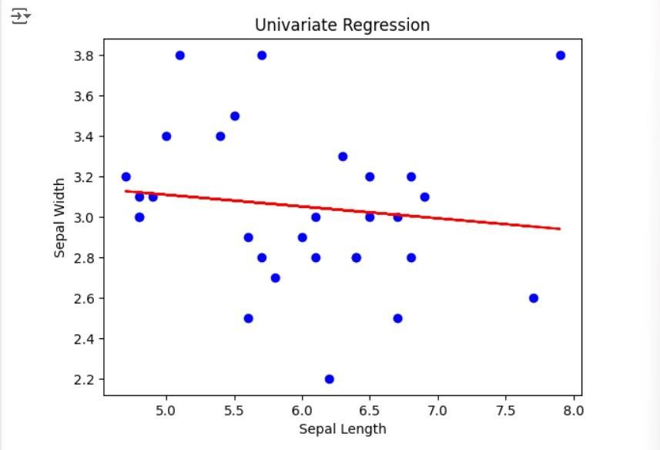

**Step 5 : Bivariate Regression**

Bivariate regression involves predicting one variable based on two predictors.

**5.1: Select the Features**

Choose two features (e.g., sepal_length, petal_length) and one target variable (e.g., sepal_width).

|  |
| --- |
| X_bi = iris[['sepal_length', 'petal_length']] |
|  |
| y_bi = iris['sepal_width'] |

**5.2: Split the Data**

Split the data into training and testing sets.

X_bi_train, X_bi_test, y_bi_train, y_bi_test = train_test_split(X_bi, y_bi, test_size=0.2, random_state=42)

**5.3: Train the Model**

Fit the linear regression model on the training data.

|  |
| --- |
| bi_model = LinearRegression() |
|  |
| bi_model.fit(X_bi_train, y_bi_train) |

**OUTPUT :**

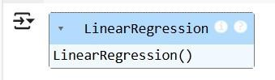

**5.4: Make Predictions**

Use the model to make predictions on the test data.

y_bi_pred = bi_model.predict(X_bi_test)

**5.5: Evaluate the Model**

Evaluate the model performance using metrics like MSE and R-squared.

|  |
| --- |
| print(f'Bivariate MSE: {mean_squared_error(y_bi_test, y_bi_pred)}') |
| print(f'Bivariate R-squared: {r2_score(y_bi_test, y_bi_pred)}') |

OUTPUT :



**5.6: Visualize the Results**

Since visualizing in 3D is challenging, we can plot the relationships between the target and each predictor separately.

|  |
| --- |
| # Sepal Length vs Sepal Width |
| plt.subplot(1, 2, 1) |
| plt.scatter(X_bi_test['sepal_length'], y_bi_test, color='blue') |
| plt.plot(X_bi_test['sepal_length'], y_bi_pred, color='red') |
| plt.xlabel('Sepal Length') |
| plt.ylabel('Sepal Width') |
| # Petal Length vs Sepal Width |
| plt.subplot(1, 2, 2) |
| plt.scatter(X_bi_test['petal_length'], y_bi_test, color='blue') |
| plt.plot(X_bi_test['petal_length'], y_bi_pred, color='red') |
| plt.xlabel('Petal Length') |
| plt.ylabel('Sepal Width') |
| plt.suptitle('Bivariate Regression') |
| plt.show() |

**OUTPUT :**

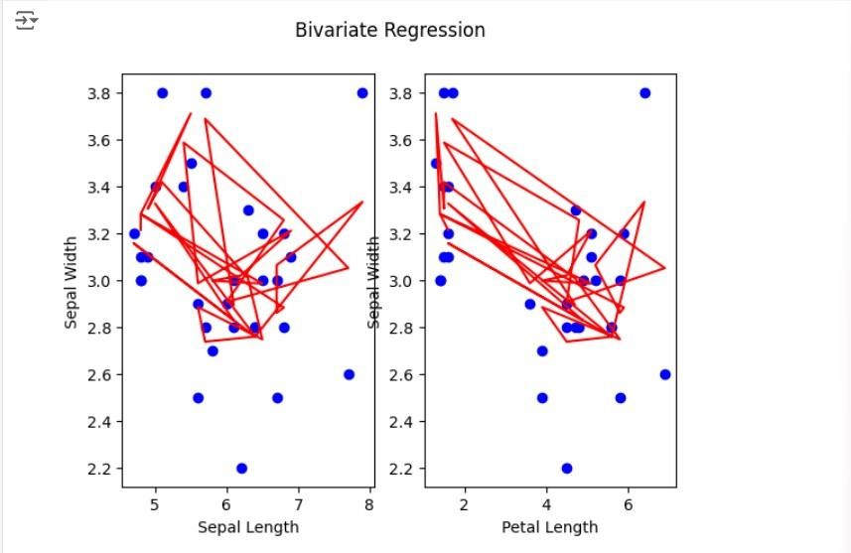

**Step 6: Multivariate Regression**

Multivariate regression involves predicting one variable based on multiple predictors.

**6.1: Select the Features**

Choose multiple features (e.g., sepal_length, petal_length, petal_width) and one target variable (e.g., sepal_width).

|  |
| --- |
| X_multi = iris[['sepal_length', 'petal_length', 'petal_width']] |
| y_multi = iris['sepal_width'] |

**6.2: Split the Data**

Split the data into training and testing sets.

|  |
| --- |
| X_multi_train, X_multi_test, y_multi_train, y_multi_test = |
| train_test_split(X_multi, |
|  |
| y_multi, test_size=0.2, random_state=42) |

**6.3: Train the Model**

Fit the linear regression model on the training data.

multi_model = LinearRegression()

multi_model.fit(X_multi_train, y_multi_train)

**OUTPUT :**

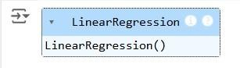

**6.4: Make Predictions**

Use the model to make predictions on the test data.

y_multi_pred = multi_model.predict(X_multi_test)

**6.5: Evaluate the Model**

Evaluate the model performance using metrics like MSE and R-squared.

print(f'Multivariate MSE: {mean_squared_error(y_multi_test, y_multi_pred)}') print(f'Multivariate R-squared: {r2_score(y_multi_test, y_multi_pred)}')

**OUTPUT :**



**Step 7: Visualize the multivariate regression**

|  |
| --- |
| plt.figure(figsize=(15,4)) |
| plt.subplot(1, 2, 1) |
| plt.scatter(X_multi_test['sepal_length'], y_multi_test, color='blue') |
| plt.plot(X_multi_test['sepal_length'], y_multi_pred, color='red') |
| plt.xlabel('sepal_length') |
| plt.ylabel('sepal_width') |
| plt.title('Multivariate Regression-1') |
| plt.show() |
| plt.figure(figsize=(15,4)) |
| plt.subplot(1, 2, 1) |
| plt.scatter(X_multi_test['petal_length'], y_multi_test, color='blue') |
| plt.plot(X_multi_test['petal_length'], y_multi_pred, color='red') |
| plt.xlabel('petal_length') |
| plt.ylabel('sepal_width') |
| plt.title('Multivariate Regression-2') |
| plt.show() |
| plt.figure(figsize=(15,4)) |
| plt.subplot(1, 2, 2 ) |
| plt.scatter(X_multi_test['petal_length'], y_multi_test, color='blue') |
| plt.plot(X_multi_test['petal_length'], y_multi_pred, color='red') |
| plt.xlabel('petal_length') |
| plt.ylabel('sepal_width') |
| plt.title('Multivariate Regression-3') |
| plt.show() |
|  |

**OUTPUT :**

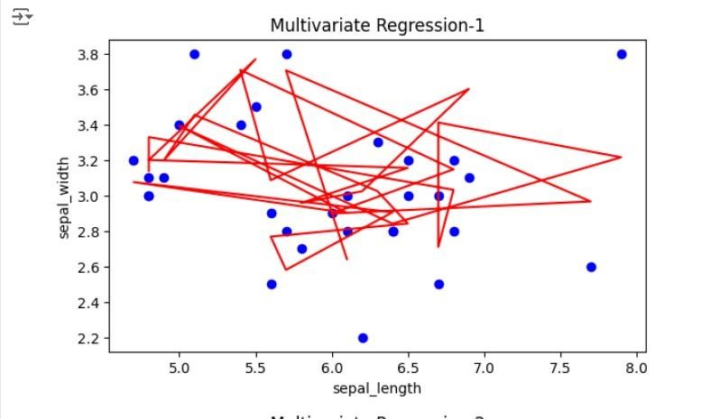

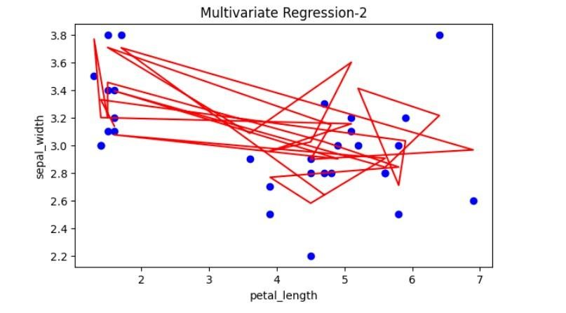

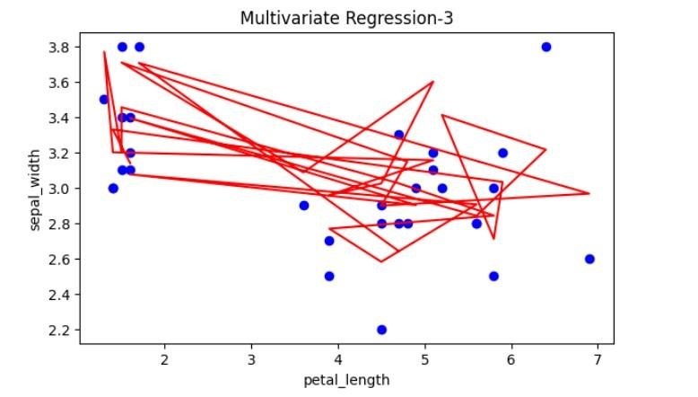

**231501083**  **Step 8: Interpret the Results**

After implementing and evaluating the models, interpret the coefficients to understand the influence of each predictor on the target variable.

|  |
| --- |
| print('Univariate Coefficients:', uni_model.coef_) |
| print('Bivariate Coefficients:', bi_model.coef_) |
| print('Multivariate Coefficients:', multi_model.coef_) |

**OUTPUT :**

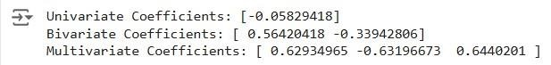

**RESULT:**

This step-by-step process will help us to implement univariate, bivariate, and multivariate regression models using the Iris dataset and analyze their performance.

**231501083**